


IFHRMS-Employee Monthly Payslip

User Manual

For

Integrated Finance and Human Resource Management System

Employee Monthly Payslip

Author: Wipro Ltd.
Creation Date: Apr 06, 2020
Last Updated:
Document Ref:
Version: 1.1

Document Control

Change Record
Date | Author | Version | Change Reference
06-Apr-2020 | Mahendheran M | 1.0
06-Apr-2020 | Vinodh G | 1.1

Reviewers
Name | Position

Requirement Discussion Panel
Sl. No. | Name | Designation/Location

Distribution
Copy No. | Name | Location
 | Wipro Project Team | Project Library
 | TN IFHRMS Team | Crystal Tool

The copy numbers referenced above should be written into the Copy Number space on the cover of each distributed copy. If the document is not controlled, you can delete this table, the Note To Holders, and the Copy Number label from the cover page.

Downloading Payslip from Portal

- Login to Portal. (IFHRMS URL: https://www.karuvoolam.tn.gov.in/tnta/home)
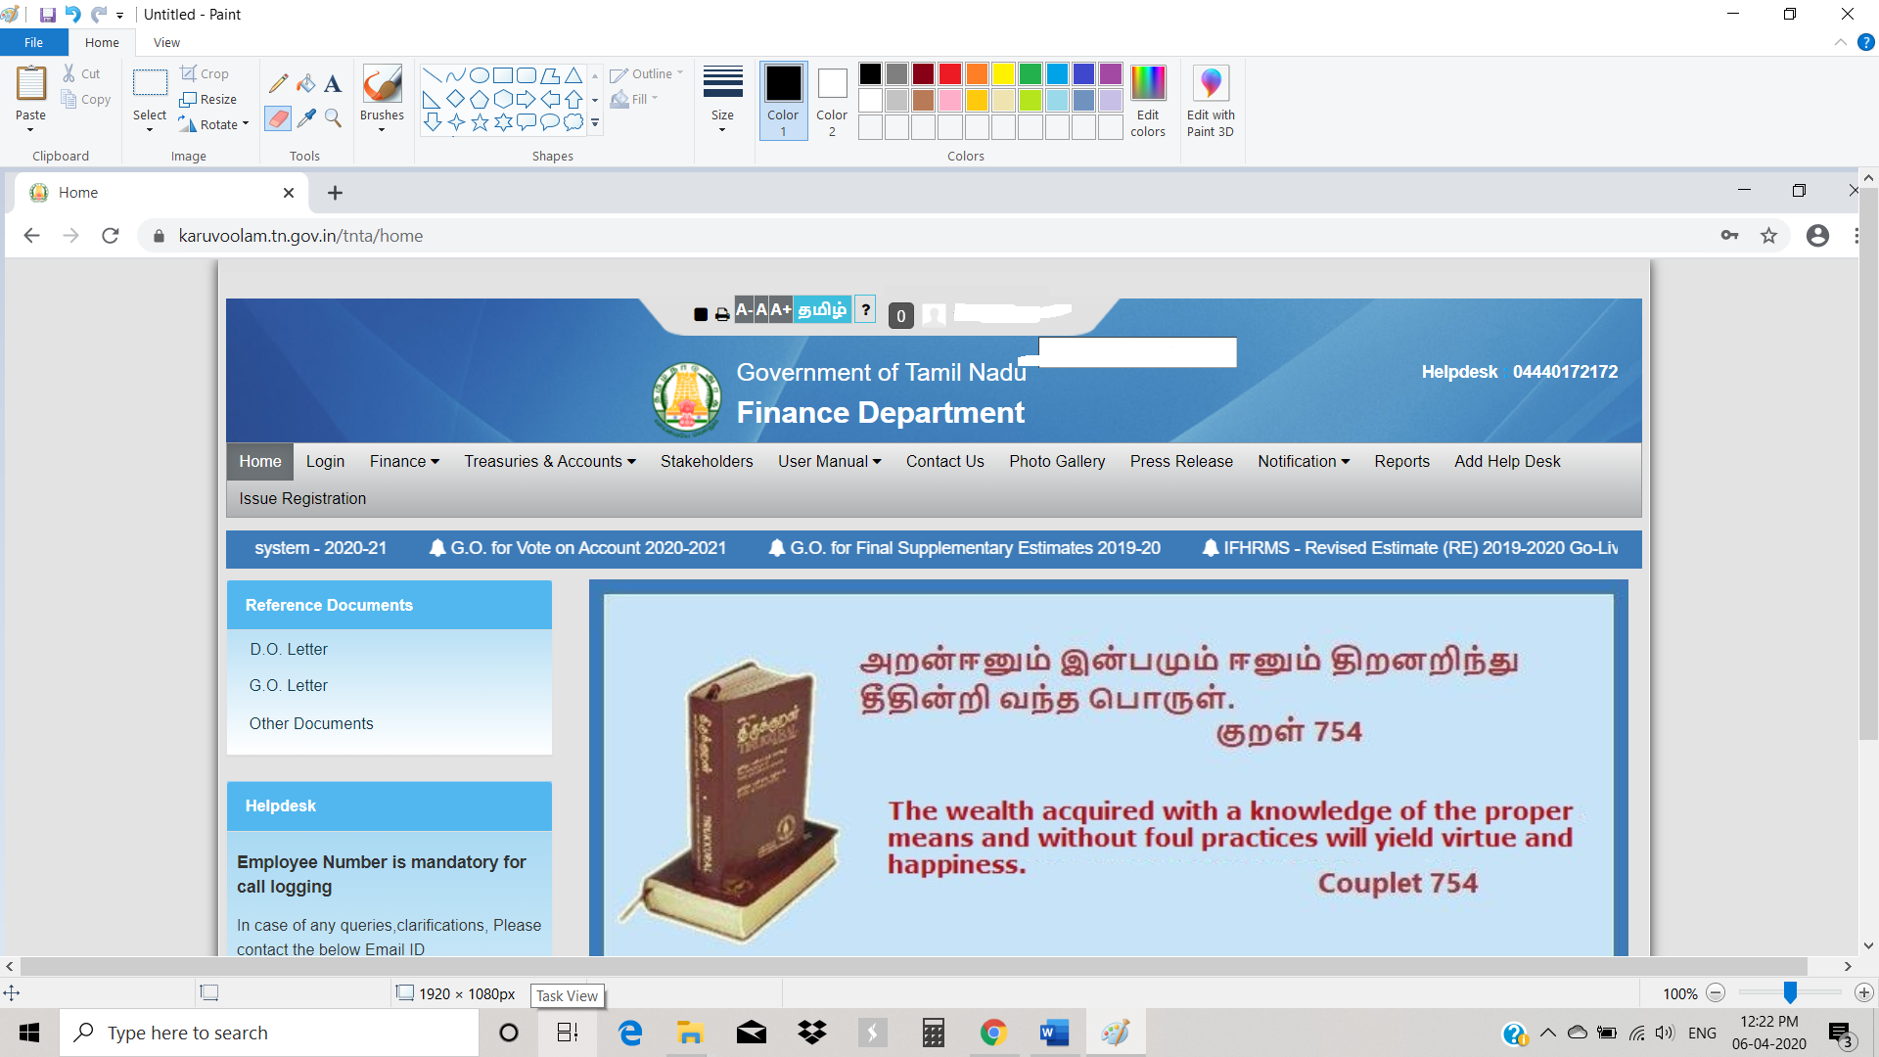

- Click on Reports TAB.
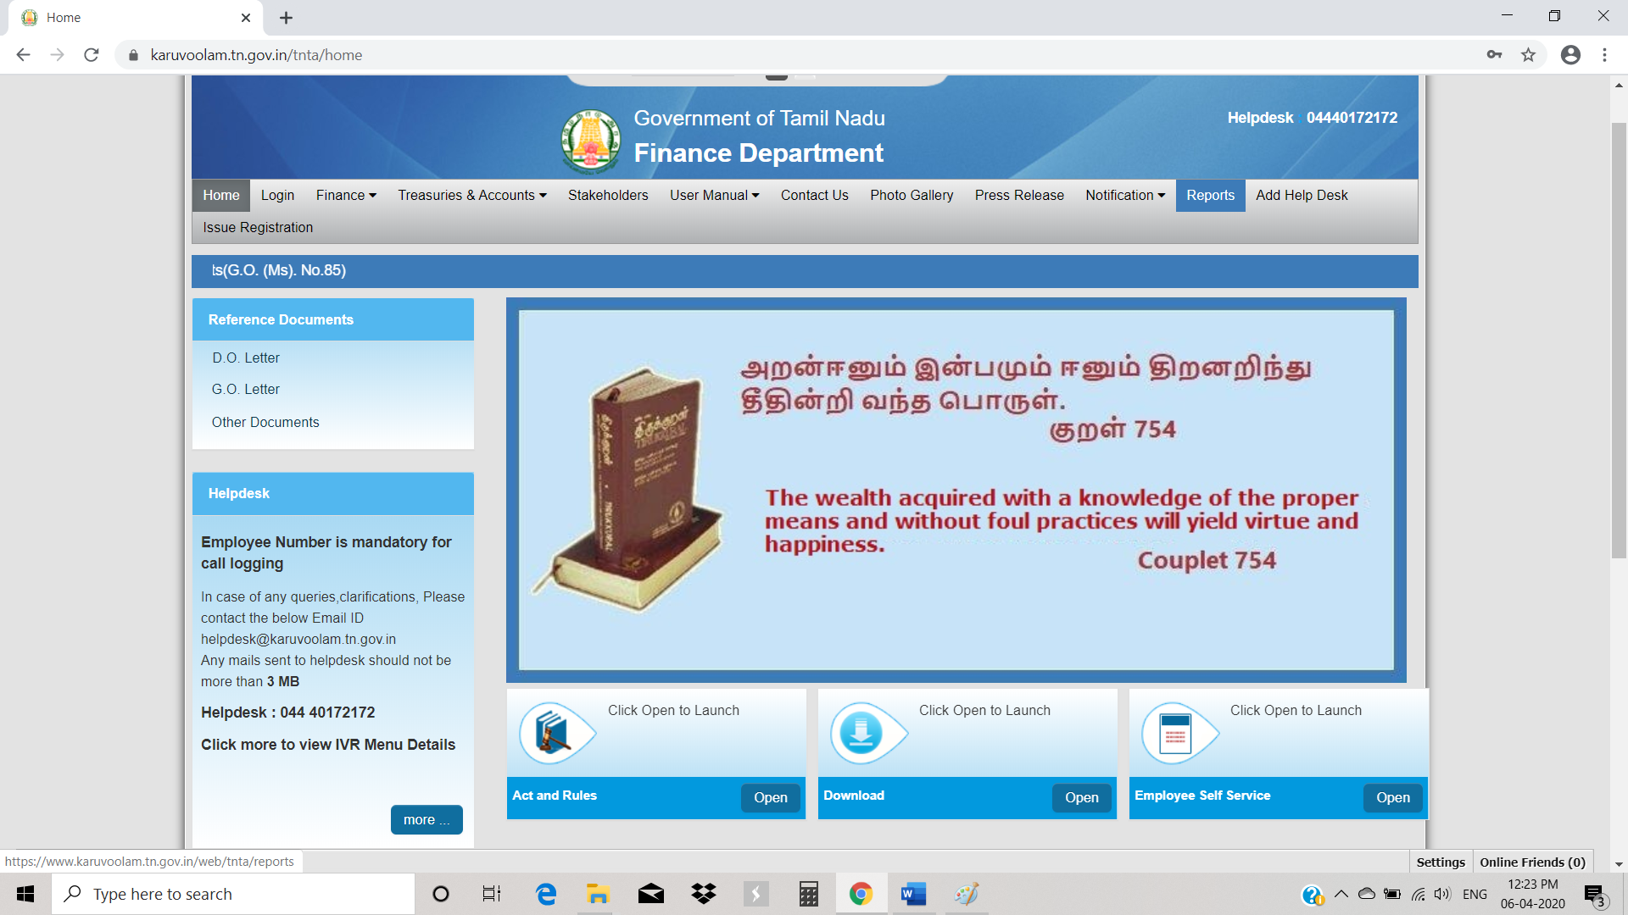

- Click PAYSLIP.
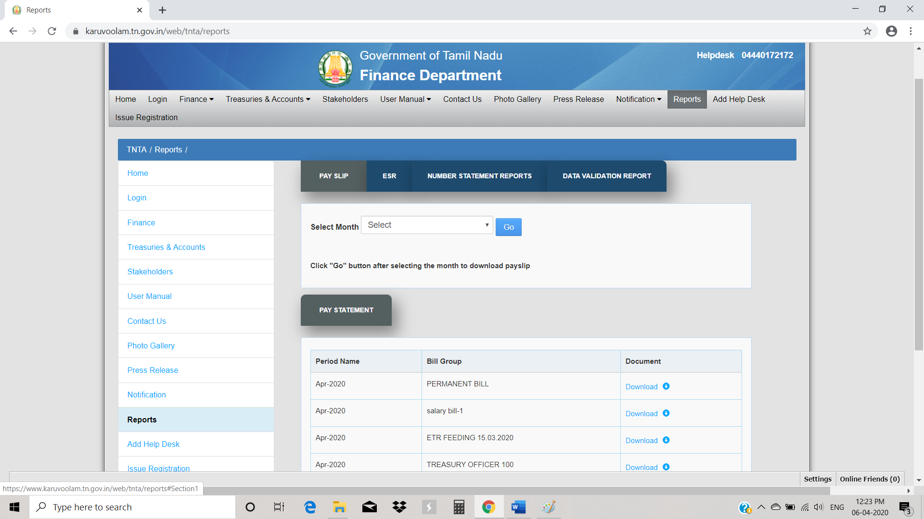
- Select Month in Payslip Panel and click on Go Button.
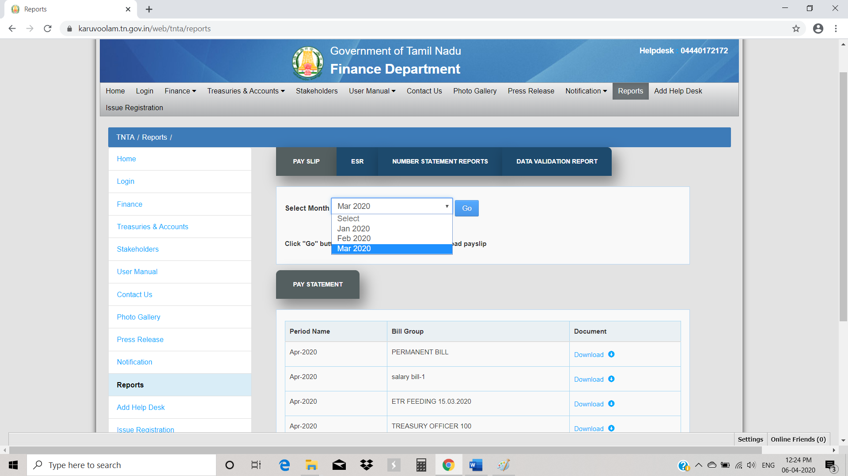

- Period and Type will get displayed. Choose Payslip Type (EMP_REGULAR_SALARY)
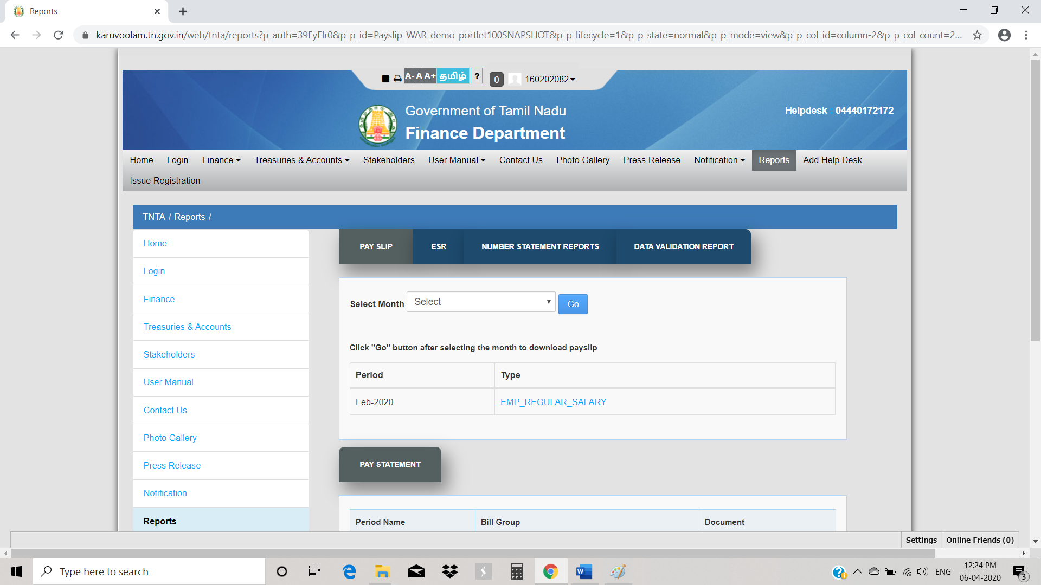

- Document will get downloaded to local hard disk.
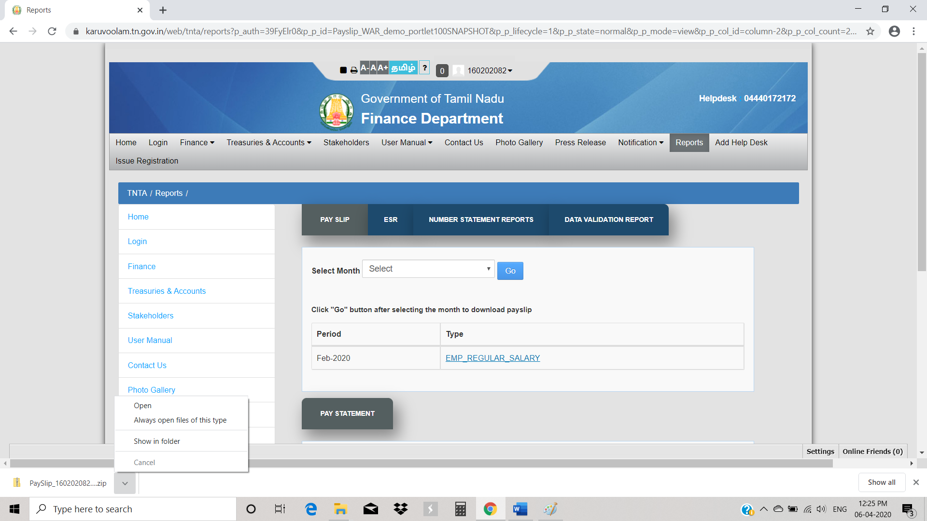
- Go to Location where payslip is downloaded and unzip the files.

Note 1: Steps to unzip downloaded file

- Launch WinZip (or) 7z from the start menu or Desktop icon. Navigate to the folder using the WinZip (or) 7z Files pane and choose the downloaded file by double clicking on it.
- Click the on the Unzip to button in the Actions pane.
- Choose the destination folder to place the uncompressed files and click "Unzip" button.
- Your extracted files will appear in the WinZip (or) 7z file pane in the selected destination folder.
(or)
- If 7z is installed in your system, then you can simply Right-click in Windows Explorer and choose "Extract Here"
Note 2: Steps to View the downloaded document
- Double-click on the file name in the folder to open file.
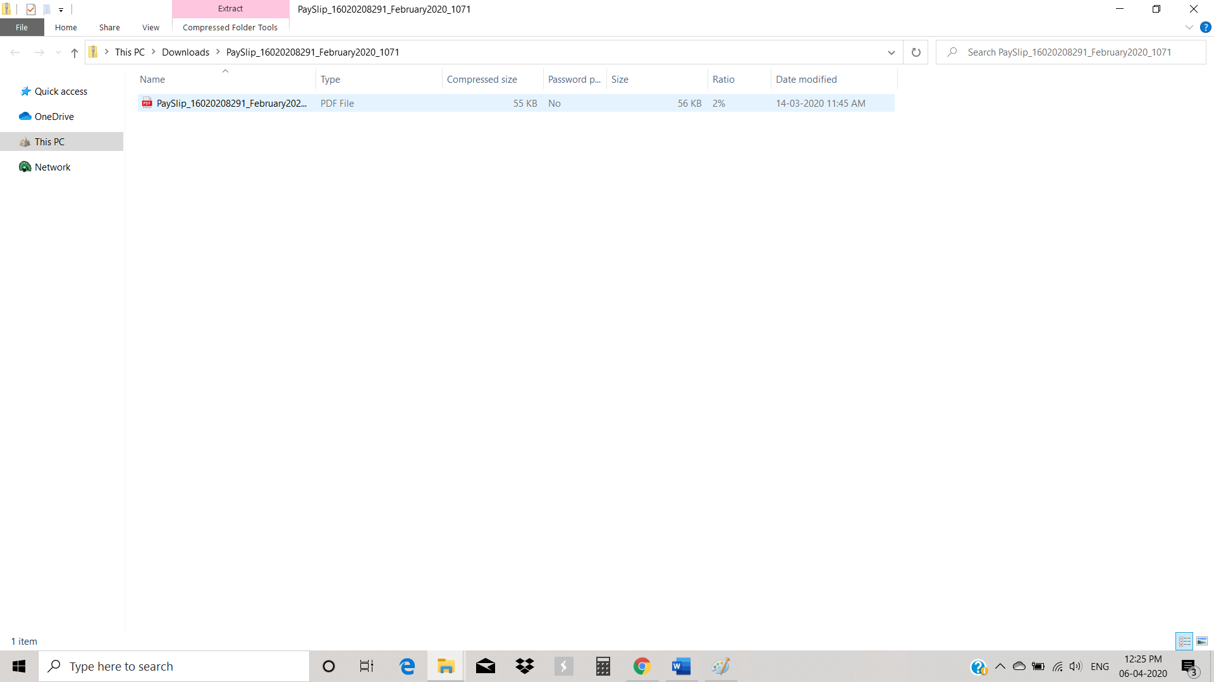
- Please enter password (Employee Date of Birth (Like: DDMMYYYY-01021988)).
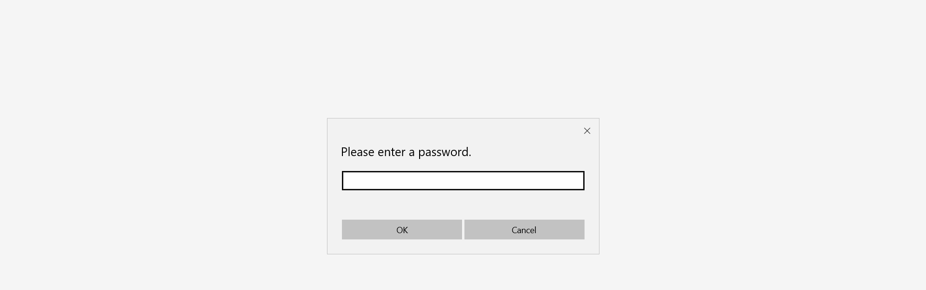
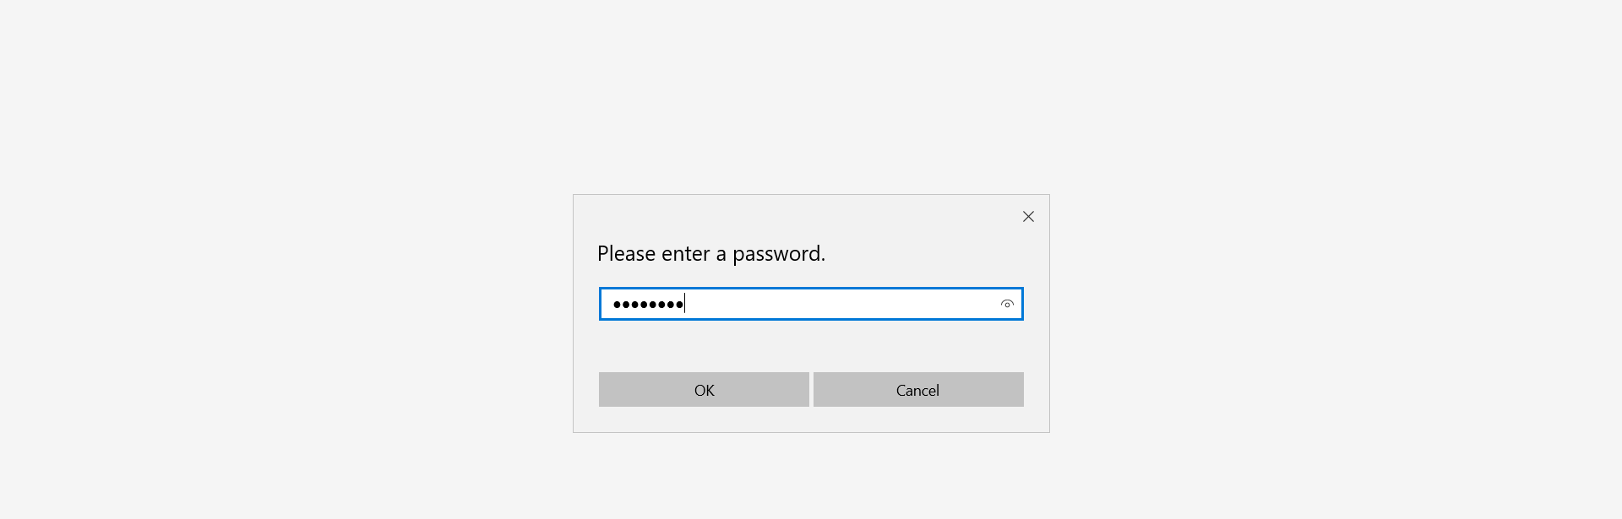
- Click OK to view Payslip for the selected` Month.
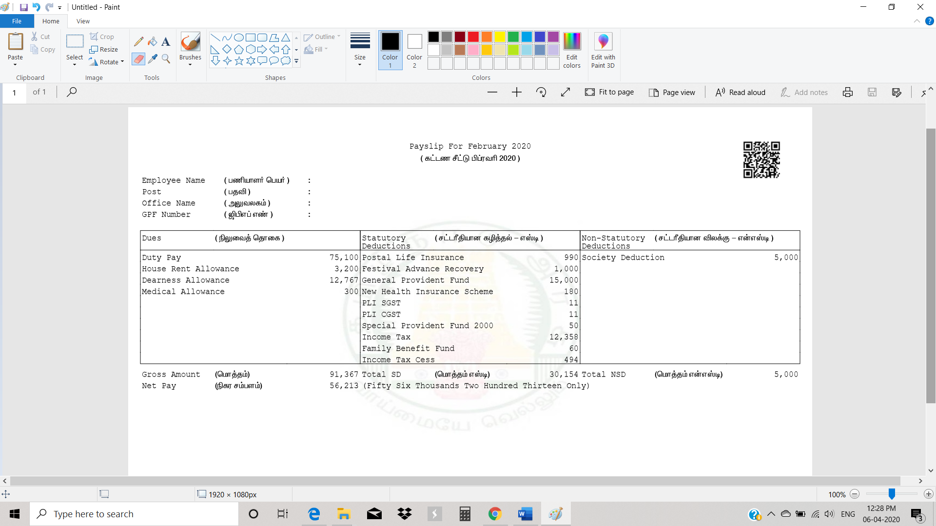

Downloading Payslip from mail

- Login to email ID linked with IFHRMS system to find the latest Payslip attached.
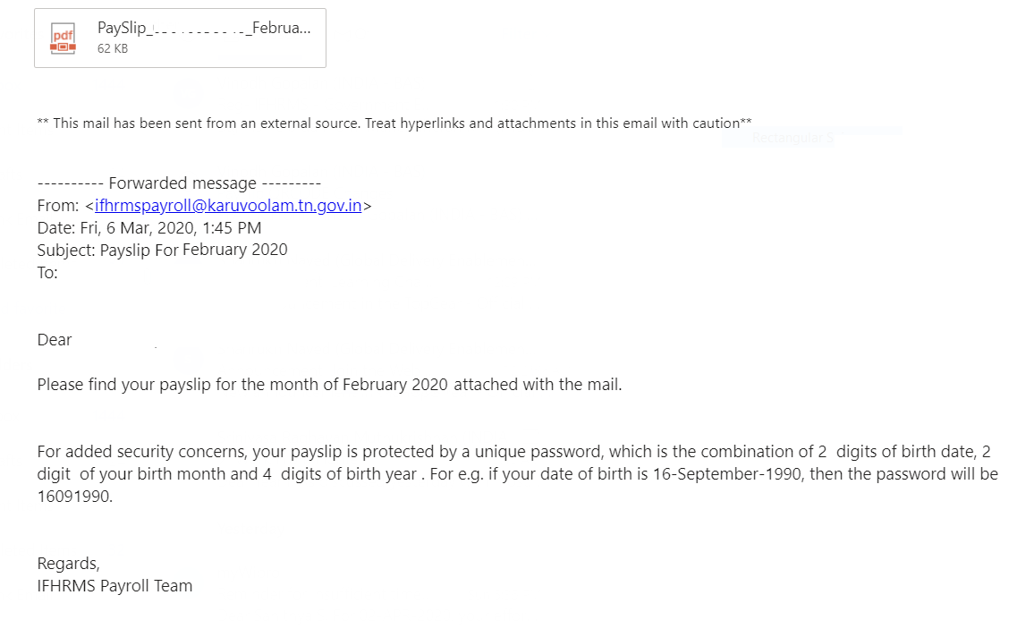

Downloading Payslip from SMS
- Click on IFHRMS Portal Page in the SMS and follow steps listed above for Portal-based payslip access.
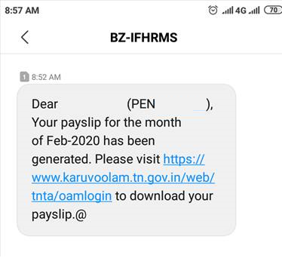

Scanning QR code from the payslip document to view details in mobile

